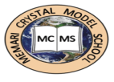**MEMARI CRYSTAL MODEL SCHOOL**

**TIME TABLE OF PA 3 (SESSION-2025-2026)**

**CLASS X**

|  |  |  |  |  |
| --- | --- | --- | --- | --- |
| DATE |  | 13/10 /25 | 14/10/25 | 15/10/25 |
| SUBJECT | 1st HALF | MATH | SSC | SCI |
|  | 2ND HALF | AI | L2 | ENG |

**Examination will be conducted in normal school timing.**